Training document for the company-wide
automation solution
Totally Integrated Automation (T I A)

MODULE B2
Analog value processing

This document was provided by Siemens A&D SCE (automation and drive technology, Siemens A&D Cooperates with Education) for training purposes. Siemens does not make any type of guarantee regarding its contents.

The passing on or duplication of this document, including the use and report of its contents, is only permitted within public and training facilities.

Exceptions require written permission by Siemens A&D SCE (Mr. Knust: E-Mail: michael.knust@hvr.siemens.de). Offences are subject to possible payment for damages caused. All rights are reserved for translation and any case of patenting or GM entry.

We thank the company Michael Dziallas Engineering and the instructors of vocational schools as well as further persons for the support with the production of the document.

PAGE:

1. Forward 4

2. Analog Signals 6

3. Data Types in STEP 7 8

4. Math Operations 9

4.1. Calculation with fixed-point numbers (INT and DINT) 9
4.2. Calculation with floating-point numbers (REAL) 10
4.3. Data type conversion operations 11

5. Input/Output Analog Values 12

5.1. Input and normalize analog value 13
5.2. Normalize and output analog value 14

The following symbols stand for the specified modules:


Information



Programming


Example exercise


Notes

1. Forward

This module B2 is assigned content wise to Additional functions of STEP 7- Programming.

Basics of

STEP 7- Programming
2 - 3 days A modules

Additional functions of
STEP 7- Programming
2- 3 days B Modules

Industrial field bus
systems
2- 3 days D modules
Process
visualization
2- 3 days F modules
Sequencer
programming
2- 3 days C modules C

IT- Communication
with SIMATIC S7
1- 2 days E modules

Learning goal:

In this module, the reader will learn about how analog values are inputted, processed, and outputted into a SIMATIC S7.

• Analog signals
• Data types in STEP 7
• Mathematical operations
• Conversion of data types in STEP 7
• Input and normalize an analog value
• Normalize and output an analog value

Requirements:

For the successful use of this module, the following knowledge is assumed:

• Knowledge in the use of Windows 95/98/2000/ME/NT4.0
• Basics of PLC- Programming with STEP 7 (e.g. Module A3 - ‘Startup’
PLC programming with STEP 7)

Required hardware and software

1 PC, Operating system Windows 95/98/2000/ME/NT4.0 with
- Minimal: 133MHz and 64MB RAM, approx. 65 MB free hard disk space
- Optimal: 500MHz and 128MB RAM, approx. 65 MB free hard disk space
2 Software STEP 7 V 5.x
3 MPI- Interface for the PC (e.g. PC- Adapter)
4 PLC SIMATIC S7-300 with at least one analog input/output module, by which a potentiometer or another analog signal transmitter is connected. Also, an analog value display must be connected to an analog output.
Example configuration:
- Power supply: PS 307 2A
- CPU: CPU 314
- Digital inputs: DI 16x DC24V
- Digital outputs: DO 16x DC24V / 0.5 A
- Analog In-/ Outputs: AI 4/ AO 2 x 8Bit
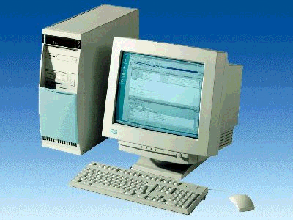
1 PC
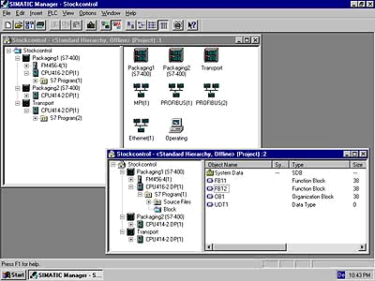
2 STEP 7

3 PC Adapter

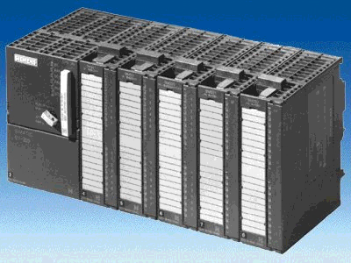
4 SIMATIC S7-300

2. Analog Signals
Contrary to a binary signal, which can only accept two signal statuses ‘Voltage available +24V‘ and ‘Voltage not available 0V‘, analog signals can also take as many values as desired within a certain range. A typical example of an analog transmitter is a potentiometer. Depending upon the position of the rotary button any resistance can be stopped here up to the maximum value.

Examples for analog measurements in control systems technology:

- Temperature -50 ... +150°C
- Flow 0 ... 200l/min
- Revolutions 500 ... 1500 R/min
- Etc...

These sizes are converted into electrical voltages, currents, or reisistances with the help of a measuring transducer. E.g. if a number of revolutions is to be collected, the speed range can be converted from 500... 1500 R/min over a measuring transducer into a voltage range from 0... +10V. At a measured number of revolutions of 865 R/min, the measuring transducer would emit a voltage level of + 3.65 V.

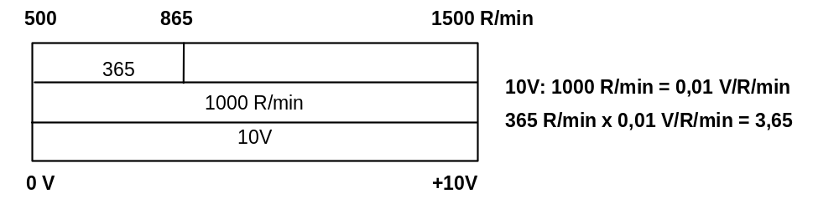

If similar measurements with a PLC are processed, then the inputted voltage, current or resistance value must be converted into digital information. One indicates this conversion as analog--digital conversion (A/D conversion). This means, that e.g. the voltage value of 3.65V is deposited as information into a row of equivalent binary digits. The more equivalent binary digits are used for the digital representation, thus the resolution becomes finer. If one would have used 1 bit e.g. for the voltage range 0... +10V, only one statement could be met, if the measured voltage in the range 0...+5V or in the range +5V...+10V. With 2 bits, the range can be partitioned into 4 single areas, 0... 2.5/2.5... 5/5... 7.5/7.5... 10V. Usually A/D conversion in control systems engineering changes with 8 or 11 bit. You have 256 single areas with 8 bits and with 11 bit a resolution of 2048 single areas.

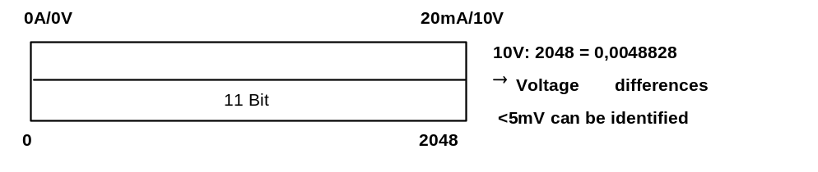

3. Data types in STEP 7
In the SIMATIC S7 there is a multiple of different data types, with which different formats of numbers are represented. In the following a complete listing of the elementary data types are given

Type and  description | Size  In Bits | Format-Options | Range and number notation  (lowest to highest values) | Example
BOOL (Bit) | 1 | Boolean text | TRUE/FALSE | TRUE
BYTE (Byte) | 8 | Hexadecimal number | B#16#0 to B#16#FF | B#16#10
WORD (Word) | 16 | Binary number | 2#0 to 2#1111_1111_1111_1111 | 2#0001_0000_0000_0000
 |  | Hexadecimal number | W#16#0 to W#16#FFFF | W#16#1000
 |  | BCD | C#0 to C#999 | C#998
 |  | Decimal number unsigned | B#(0,0) to B#(255,255) | B#(10,20)
DWORD (Double word) | 32 | Binary number | 2#0 to 2#1111_1111_1111_1111_1111_1111_1111_1111 | 2#1000_0001_0001_1000_1011_1011_0111_1111
 |  | Hexadecimal number | DW#16#0000_0000 to DW#16#FFFF_FFFF | DW#16#00A2_1234
 |  | Decimal number unsigned | B#(0,0,0,0) to B#(255,255,255,255) | B#(1,14,100,120)
INT (Integer) | 16 | Decimal number signed | -32768 to 32767 | 1
DINT (Int,32 bit) | 32 | Decimal number signed | L#-2147483648 to L#2147483647 | L#1
REAL (Floating-point number) | 32 | IEEE floating-point number | Upper limit: +/-3.402823e+38  Lower limit: +/-1.175495e-38 | 1.234567e+13
S5TIME  (Simatic-Time) | 16 | S7-Time in steps of 10 ms | S5T#0H_0M_0S_10MS to S5T#2H_46M_30S_0MS and  S5T#0H_0M_0S_0MS | S5T#0H_1M_0S_0MS  S5TIME#1H_1M_0S_0MS
TIME  (IEC-Time) | 32 | IEC-Time in steps from 1ms, integer signed | -T#24D_20H_31M_23S_648MS to  T#24D_20H_31M_23S_647MS | T#0D_1H_1M_0S_0MS  TIME#0D_1H_1M_0S_0MS
DATE  (IEC-Date) | 16 | IEC-Date in step of 1 day | D#1990-1-1 to D#2168-12-31 | DATE#1994-3-15
TIME_OF_DAY (Time) | 32 | Time in steps of 1ms | TOD#0:0:0.0 to TOD#23:59:59.999 | TIME_OF_DAY#1:10:3.3
CHAR (Character) | 8 | ASCII-Characters | ´A´, ´B´ etc. | ´B´
Note : For analog value processing, Data types INT and REAL play a big role, because inputted analog values exist as real numbers in the format INT. Due rounding errors by INT, only real numbers REAL come into question for an accurate further processing.

4. Math operations
4.1 Calculation with fixed-point numbers (INT and DINT)
With fixed-point numbers, the mathematical unit operations addition, subtraction, multiplication and division are possible. However the places after the decimal point remain unconsidered, which lead to rounding errors with the division.

Operation | Size in Bit | Function
+I | 16 | Add the contents of the low-order word of ACCUs 1 and 2 and save the result in the lower-order word of the ACCU 1.
-I | 16 | Subtract the contents of the low-order word of ACCU 1 from the contents of the low-order word of ACCU 2 and saves the result in the low-order word of ACCU 1.
*I | 16 | Multiply the contents of the low-order word of ACCUs 1 and 2 and  save the result (32 Bit) in ACCU 1.
/I | 16 | Divide the contents of the low-order word from ACCU 2 by the contents of  low-order word of ACCU 1. The result is saved in the low-order word of ACCU 1. The remainder is saved in the high-order word of the ACCU 1.
+D | 32 | Add the contents of the ACCUs 1 and 2 and saves the result in ACCU 1.
-D | 32 | Subtract the contents of ACCU 1 from the contents of ACCU 2 and save the result in ACCU 1.
*D | 32 | Multiply ACCU 1 with the contents of ACCU 2 and save the result in  ACCU 1.
/D | 32 | Divide the contents of ACCU 2 by the contents of ACCU 1 and save the  Quotient in ACCU 1.
MOD | 32 | Divide the contents of ACCU 2 by the contents of ACCU 1 and saves the remainder as a result in ACCU 1.

4.2 Calculation with floating-point numbers (REAL)
With floating-point numbers, a multiple of mathematical operations can be accomplished. The positions to the right of the decimal point are always considered here.

Operation | Function
+R | Add the floating-pt. numbers (32 Bit, IEEE-FP) in the ACCUs 1 and 2 and save the 32-Bit-  Result in ACCU 1.
-R | Subtract the floating-pt. number (32 Bit, IEEE-FP) in ACCU 1 from the floating pt. number (32 Bit, IEEE-FP) in ACCU 2 and save the 32-Bit-result in ACCU 1.
*R | Multiply the floating-pt. number (32 Bit, IEEE-FP) in ACCU 1 with the floating-pt. number (32 Bit, IEEE-FP) in ACCU 2 and save the 32-Bit-result in ACCU 1.
/R | Divide the floating-pt. number (32 Bit, IEEE-FP) in ACCU 2 by the floating-pt. number  (32 Bit, IEEE-FP) in ACCU 1. The 32-Bit-result is saved in ACCU 1.
SQRT | Calculate the square root of the floating-pt. number (32 Bit, IEEE-FP) in ACCU 1 and save the  32 Bit-result in ACCU 1.
SQR | Calculate the square of the floating-pt. number (32 Bit, IEEE-FP) in ACCU 1 and save the 32  Bit-result in ACCU 1.
LN | Calculate the natural log of the floating-pt. number (32 Bit, IEEE-FP) in ACCU 1 and  Save the 32 Bit-result in ACCU 1.
EXP | Calculate the exponential value of the floating-pt. number (32 Bit, IEEE-FP) to base e and save  32 Bit-result in ACCU 1.
SIN | Calculate the sine the floating-pt. number (32 Bit, IEEE-FP) in ACCU 1 and save the  32 Bit-result in ACCU 1.
COS | Calculate the Cosine of the floating-pt. number (32 Bit, IEEE-FP) in ACCU 1 and save the  32 Bit-result in ACCU 1.
TAN | Calculate the tangent of the floating-pt. number (32 Bit, IEEE-FP) in ACCU 1 and save the  32 Bit-result in ACCU 1
ASIN | Calculate the arcsine of the floating-pt. number (32 Bit, IEEE-FP) in ACCU 1 and save the  32 Bit-result in ACCU 1.
ACOS | Calculate the arccosine of the floating-pt. number (32 Bit, IEEE-FP) in ACCU 1 and save the  32 Bit-result in ACCU 1.
ATAN | Calculate the arctangent of the floating-pt. number (32 Bit, IEEE-FP) in ACCU 1 and save the 32 Bit-result in ACCU 1.

4.3 Data type- conversion operations
Since the numbers do not often exist for the further processing of important number formats, these numbers must be adjusted with help of the conversion operations.

Operation | Function
BTI | BCD converted into an integer (16 Bit). This operation converts a binary-coded decimal  in ACCU 1 into an integer (16 Bit).
BTD | BCD converted into an integer (32 Bit). This operation converts a binary-coded decimal in ACCU 1 into an integer (32 Bit).
ITB | Integer (16 Bit) converted into BCD. This operation converts an integer (16 Bit) in the low-order word of the ACCU 1 into a binary-coded decimal value.
ITD | Integer (16 Bit) converted into an integer (32 Bit). This operation converts an integer (16 Bit) in the  low-order word of the ACCU 1 into an integer (32 Bit).
DTB | Integer (32 Bit) converted into BCD. This operation converts an integer (32 Bit) in ACCU 1 into a binary-coded decimal value.
DTR | Integer (32 Bit) converted into integer (32 Bit, IEEE-FP). This operation converts an integer  (32 Bit) in ACCU 1 into an integer (32 Bit, IEEE-FP).
RND | Round for integer. This operation rounds the converted number to the next integer.  When the fraction of the converted number is exactly between an even and uneven result, the operation choose the even result.
RND+ | Round to the next highest integer. This operation rounds the converted number to the smallest integer, that is greater than or equal to the converted integer.
RND- | Round to the next lowest integer. This operation rounds the converted number to the largest integer, that is smaller or equal to the converted integer.
TRUNC | Round with truncation. This operation converts the whole part of the integer.
Note: In the case of analog value processing, the analog value lies in INT and should be converted for accurate further processing because of the round error by INT in integer REAL. Since the conversion is not direct, it must first convert ITD into
DINT and then into REAL with DTD.
.

5. Inputting/outputting analog values
Analog values are inputted as word information in the PLC. Respectively, the access of this word is performed with the instructions:

L PIW x for ‘Load analog input word’
T PQW x for ‘Transfer analog output word’

Each analog value (“Channel“) allocates a peripheral input-output word. The format is an integer
INT.

The addressing of the in and/or output words depends on the module start address. If the analog module is placed in slot 4, then it has the default start address 256. The start address of each further analog module increases by 16 for each slot. This default start address can be checked in the hardware configuration table under a detailed view.

The address of the first analog input would be on slot 6 PIW 288 with an analog input. Those of the second analog input on PIW 290, those of the first analog output on PQW 288 etc. .

The analog value transformation to the further processing in the PLC (digitized) is equal to analog input and output.
For the module SM334, with 4 analog inputs and 2 analog outputs, with the analog image processing
from 0 to 10V as well as 0 to 20mA, the digitized value range appears as follows:

Nominal range of the
analog value

Digitized value to be further
processed in the PLC
0A/0V 10mA/5V 20mA/10V

0 13824 27648

These digitized values must often be normalized through corresponding further processing in the PLC.

5.1. input and Normalize analog value
If an analog value is presented as a digitized value, it must still be normalized before it can be processed in the PLC.
Likewise, the analog output from the peripheral output value follows after the normalization of the output value.

In a STEP 7- Program, normalizing is caught in the math operation.
For this reason, the math operation can take place as accurately as possible. The values to be normalized must be converted into the data type REAL so that the rounding errors are at a minimum.
Exercise:

In the following example, a value from 0 to 10V with an analog module SM334 in slot 6 is inputted (PIW288). It is first presented as an INTEGER (16 Bit) and should be normalized from 100 to 1000 in REAL format and saved in the memory bit double word MD10.
Solution in STL:

L PIW 288 //Analog value input 0 to 10 V contains 0 to 27648 integers (16 Bit)
ITD //Value of integer (16 Bit) converted into integer (32 Bit)
DTR //Value of integer (32 Bit) converted into a real number
L 2.7648e+4 //
/R //Division with real number 27648
L 9.000e+2 //
*R // Multiplication with real number 900 (1000-100)
L 1.000e+2 //
+R // Addition with real number 100 (Offset)
T MD10 //Normalized value 100 to 1000 in real format

5.2. Normalize and output analog value
If a standardized value is present and is to be used on an analog output module, then it must be normalized.
In a STEP 7- Program, normalizing is caught in the math operation. This occurs in the data type REAL so that the rounding errors are at a minimum. This value is only then rounded to an integer value. The places behind the decimal point are however lost.
Example:

In the following example, a value from 100 to 1000 is saved in real format in memory bit double word MD20 and should be outputted normalized from 0 to 10V with an analog module SM334 (PQW288) .
Solution in STL:

L MD20 // Value 100 to 1000 in real format
L 1.000e+2 //
-R // Subtraction with real number 100 (Offset)
L 9.000e+2 //
/R // Division with real number 900
L 2.7648e+4 //
*R // Multiplication with real number 27648
RND // Round to an integer
T PQW 288 // 0 to 27648 real number (16 Bit) corresponds to analog value output 0 to 10 V

